Global Land Temperature Change

1. Introduction
Domain:
Three regions of knowledge support the project:
- Climate Science and Environmental Analytics along with Data Visualization.
- The investigation employs modern visualization techniques to study essential environmental scientific problems about climate change patterns within regions while tracking their spreading distribution.

Problem Overview:
- Human civilization confronts the most crucial environmental challenge of climate change at the beginning of the twenty-first century.
- Through pre-industrial times to the present day the planet experienced 1.1°C warming mostly affecting ecosystems and human health and economies adversely.
- Social economic activities lead to most global temperature increase through their release of fossil fuels and industrial development and reshaped patterns of land use.
- Understanding the process of global warming generation helps authorities create effective climate policy solutions.

Project Objective:
The analysis of global land temperature patterns from 2000 to 2015 requires Python (Dash, Plotly) alongside Tableau to achieve a comprehensive evaluation through two visualization solutions.
Through both static and interactive dashboards, the project aims to:
- The evaluation demonstrates the worldwide pattern of temperature growth along with regional climate changes.
- A visualization system should show every difference of nation ownership over land and all detected anomalies.
- Measure temperature uncertainty over time.
- Users can explore climate information in greater depth because of the development of basic and interactive dashboard interfaces.
- Visual storytelling serves as a tool to help evidence-based climate decision-making through supportive information about climate awareness.

2. Problem Statement
- The Earth experiences an accelerated climate emergency that emerges from elevated mean temperature levels and adjustments in atmospheric conditions.
- Researchers studied world land surface temperature changes from 2000 to 2015 to identify regional disparities along with their pattern abnormalities and effects of global warming. Monitoring temperature information while developing visual patterns represents the principal obstacle in this research.
Solving this problem matters because it enables improved resource management policies as well as climate change decisions and better awareness strategies through the identification of temperature areas and patterns.
  - Static reports are insufficient for showing the complete set of characteristics in climate data that spans across various geographic areas.
  - Python Dash and Plotly alongside Tableau provide users with interactive visualizations that let them check dynamic patterns as well as view specific country-level information to grasp crucial climate change elements.
  - The interactive design feature of dashboards enables complicated climate datasets to display concise visuals which assist politicians along with research teams and ordinary citizens to make knowledgeable choices based on solid quantitative data findings.

3. Methodology

Workflow Overview
Start
↓
Berkeley Earth Data Collection (Kaggle)
↓
Loading Data into Python (pandas)
↓
Data Cleaning and Preprocessing
↓
Feature Engineering (Rolling Averages, Aggregations)
↓
Static Visualizations (Line, Scatter, Box, Histogram, Choropleth)
↓
Building Python Interactive Dashboard (Dash, Plotly)
↓
Loading Cleaned Data into Tableau
↓
Tableau Static Visualizations and Dashboard Creation
↓
Insights and Results Analysis
↓
Final Project Report and Submission
↓
End

- Data Collection
- Downloaded dataset from Kaggle.
- Data Cleaning
- The data cleaning process included removing temperature value errors and setting the time frame from 2000 to 2015. \

- Feature Engineering
- Feature Engineering required the generation of new features which included rolling average calculations.
- Static Visualization
- The initial patterns appeared within plots that I developed during Static Visualization.
- Dashboard Development:
- Python (Dash) Dashboard with interactive visualizations.
- Tableau Dashboard with multi-chart integration.
- Analysis and Insights Extraction:
- The process of extracting valuable insights from visual representations included proper trend identification through interpretation of analysis results.
The project made use of Python (Dash, Plotly, Pandas) along with Tableau as the main tools.

4. Data Abstraction
Dataset Details:
The dataset named Global Land Temperatures by Country combines date (dt) information with country (Country) identification.
- Name: Global Land Temperatures by Country
- Source: Kaggle (Berkeley Earth)
- Attributes:
  - dt (Date)
  - AverageTemperature
  - AverageTemperatureUncertainty
  - Country
- Size: ~577,000 records
- Type: Structured dataset
Attributes Description:
- dt: Date on which the temperature was recorded
- AverageTemperature: Average land surface temperature
- AverageTemperatureUncertainty: Confidence interval of measurement
- Country: Name of the country where the observation was made
The observation took place within the territory called Country. The database underwent filtering to keep the years from 2000 to 2015 while being designed to connect with socio-economic databases for potential collaboration.
5. Task Abstraction
Target:
The main project objective is to find major discoveries along with identified trends and atypical events regarding global land surface temperature fluctuations from 2000 through 2015.
Specifically, the project aims to:
- This work establishes long-term temperature changes as well as associated trends in both global and domestic areas.
- A detailed analysis must be performed to evaluate temperature uncertainty and its spatial and temporal patterns.
- Researchers need to identify how polar areas exhibit faster temperature rises when compared to equatorial regions.
- The analysis must present statistical charts to visualize temperature distribution patterns together with significant extreme events.
Actions:
The following methods together with techniques enabled the accomplishment of these targets:
Data aggregation: The researchers performed data aggregation on yearly national totals to generate yearly averages.
Filtering: Restricted data to the years 2000–2015 for relevance and completeness.

Feature Engineering: The implementation of rolling averages integrated into the system achieved goal-based feature engineering by both dampening random variations and showing genuine patterns.
Searching and Querying: The platform allows users to select particular nations and temperature parameters and historical periods for complete data analysis through search and query functions.
Static Visualizations: The analysis used static visual representations through line charts and scatter plots as well as box plots and histograms and choropleth maps for pattern discovery.
Interactive Dashboards: Developed dynamic filters and selections in Python (Dash) and Tableau for deeper exploration. All three components worked together to produce extensive insights about climate pattern changes during the chosen time period.
6.Implementation Using Tools

Python Implementation
Data preprocessing involved the following steps:
- The refinement includes changing Average_Temperature to Avg_Temp.
- The analysis dropped all rows which contained missing entries for temperature or country identifiers.
- Mean values were calculated through data grouping which employed both Country and Year divisions.
- The data contains rolling averages calculated with a three-year window which standardizes annual irregularities.
Python libraries used:
- pandas, numpy for data processing
- plotly.express and plotly.graph_objs for visualizations
- dash and jupyter_dash for dashboard creation

Python Visualizations

Line Chart: Average Temperature Over Time
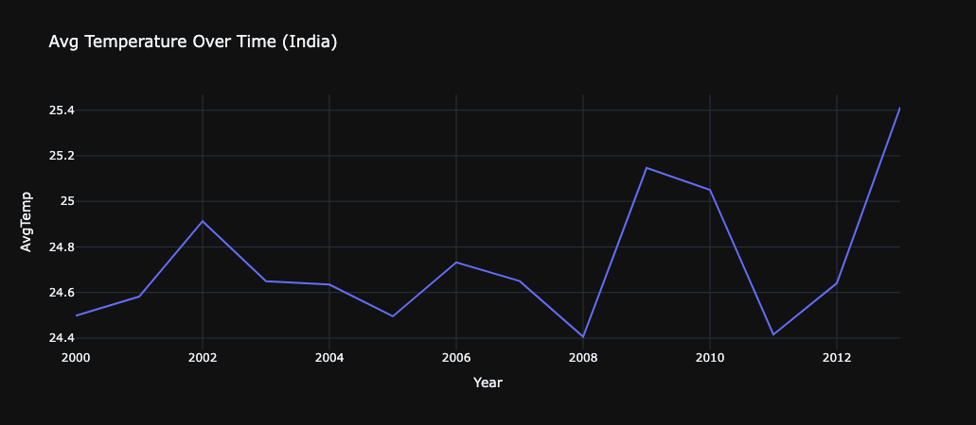
Description: Displays the trend of average temperature for the selected country over years.
Insights: The data reveals that India experienced a steady rise in temperature levels starting from 2000 demonstrating a deterioration of climate change effects.

Scatter Plot: Year vs Temperature Uncertainty
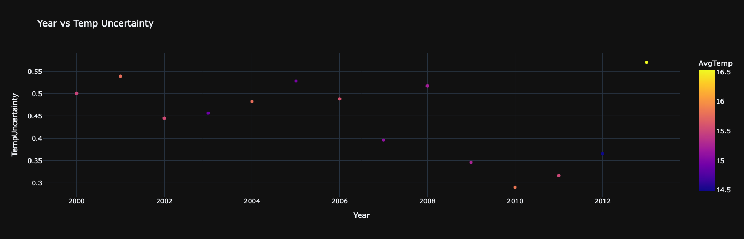
Description: Plots temperature uncertainty against years.
Insights: The level of uncertainty in measurements changes over time because developed areas show lower measurement uncertainty. This done for Afghanistan country as a example

Box Plot: Temperature Distribution
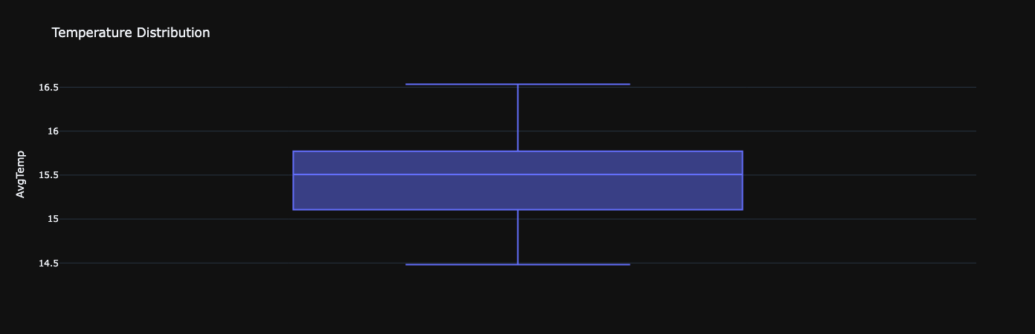
Description: Displays the spread and outliers of average temperatures.
Insights: The temperature range in Russia extends widely showing that the country experiences severe fluctuations between cold and hot climates. This plot is for Afghanistan

5.4 Histogram: Temperature Frequency Distribution
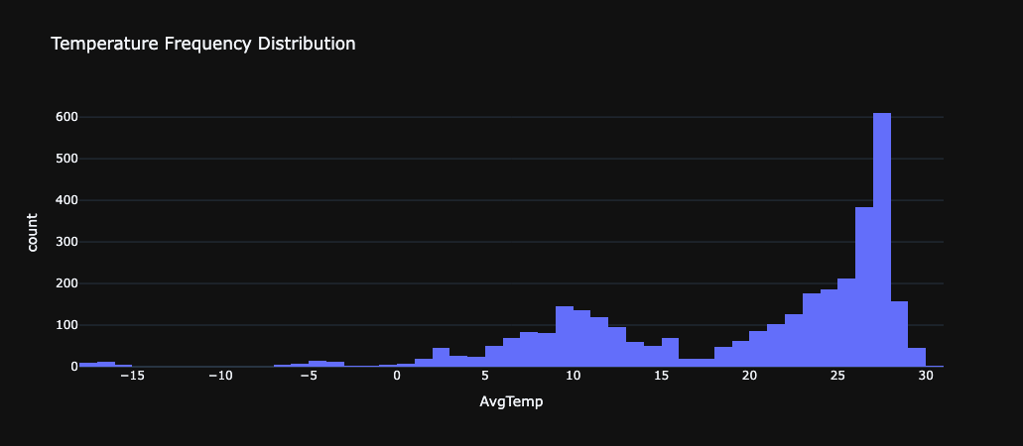
Description: Shows the frequency of average temperatures recorded.
Insights: Personal temperature data fall within 10°C and 30°C for most national regions.

Choropleth Map: Global Temperature Visualization
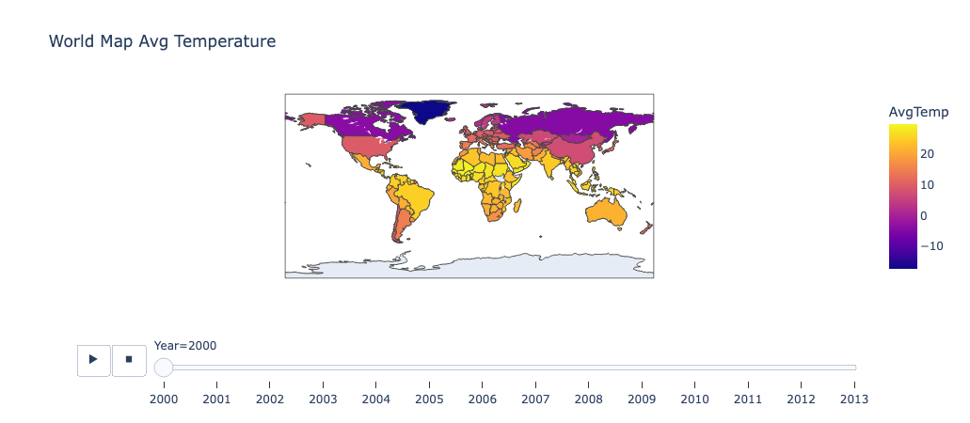
Description: The system interactively colors worldwide country territories based on their annual temperature averages through an animated display.
Insights: The Arctic region shows greater temperature increase than worldwide average temperatures through polar amplification.

Python Dashboard
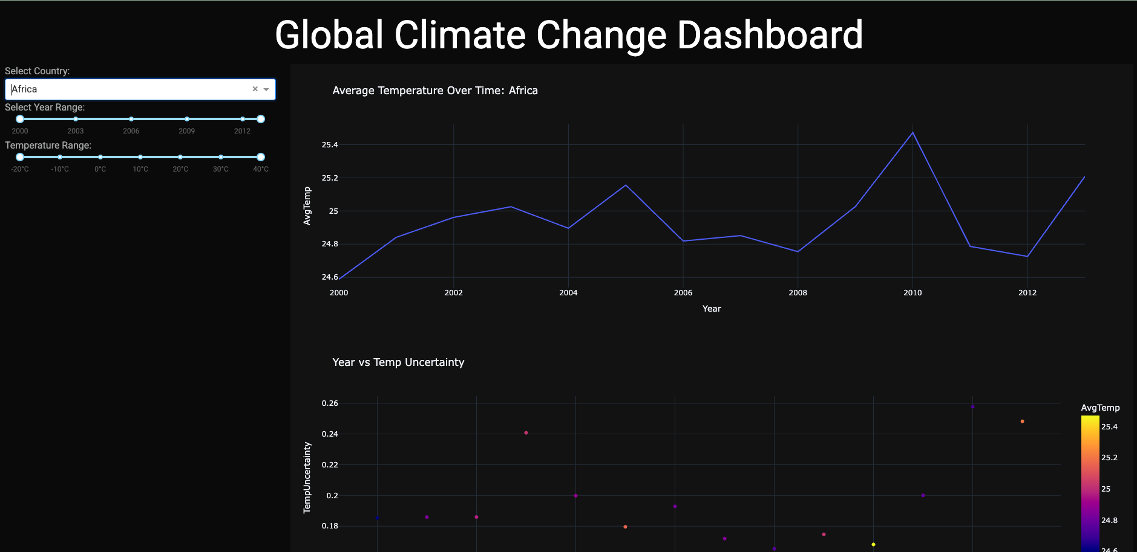

Dashboard Layout
- Sidebar (Left): Filters for Country, Year Range, Temperature Range.
- Main Content (Right):
  - Line Chart
  - Scatter Plot
  - Box Plot
  - Histogram
  - Choropleth Map

Filters
- Country Dropdown: Select country
- Year Range Slider: Filter by year range (2000–2015)
- Temperature Range Slider: Focus on specific temperature ranges

Features
- Built with Dash and Plotly.
- Dark professional theme.
- Opens in a new browser tab (mode='external').
Dashboard URL: http://127.0.0.1:8050/
Insights:
- It enables users to deeply explore both geographical and worldwide temperature patterns.
- Through user interaction systems enable users to find patterns easily and effectively.

Tableau Visualizations

Map View of Average Temperatures
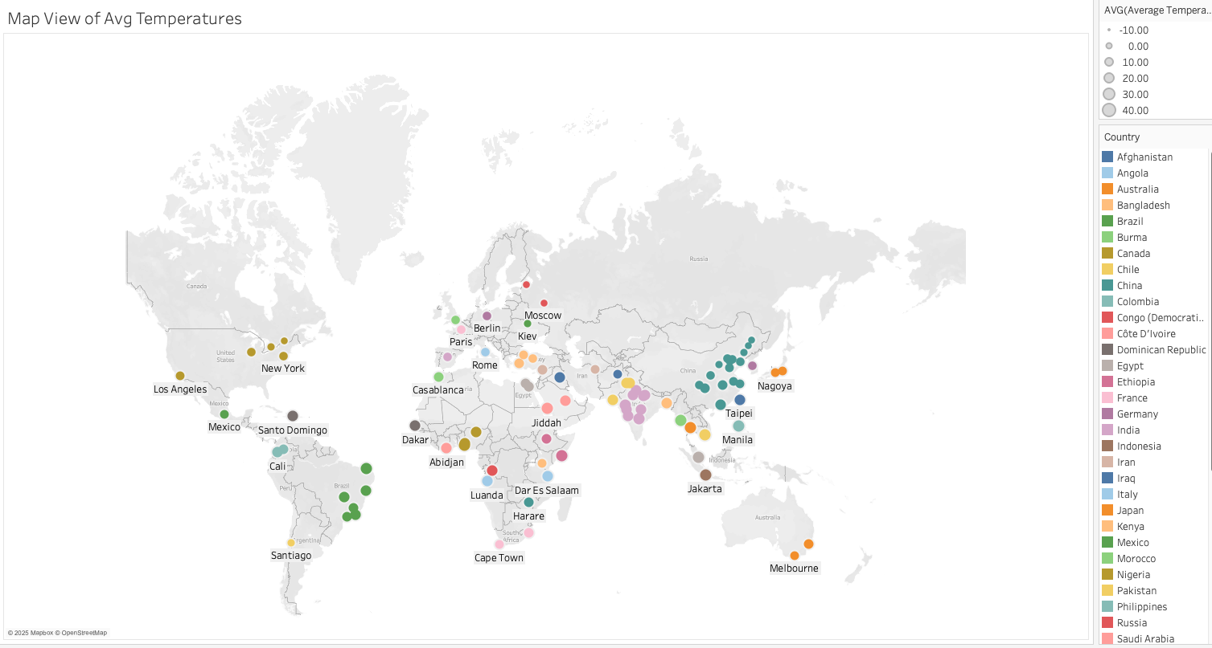
Description: Displays country-wise average land surface temperatures.

Temperature Uncertainty Map
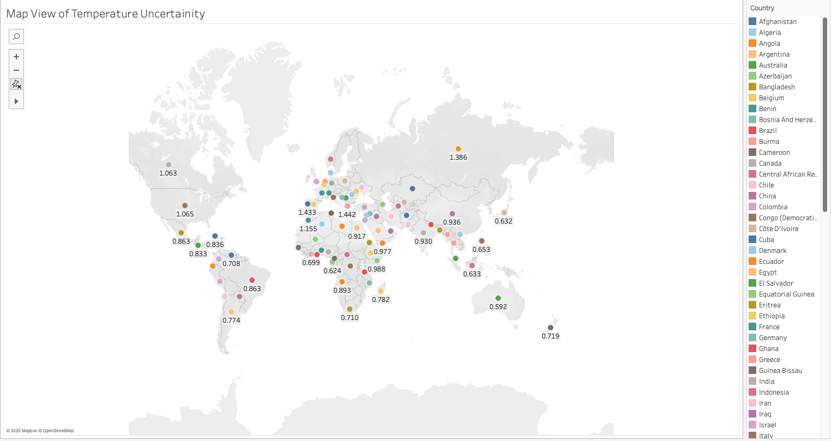
Description: Highlights regions with high uncertainty in temperature measurements.

Top 10 Coldest States
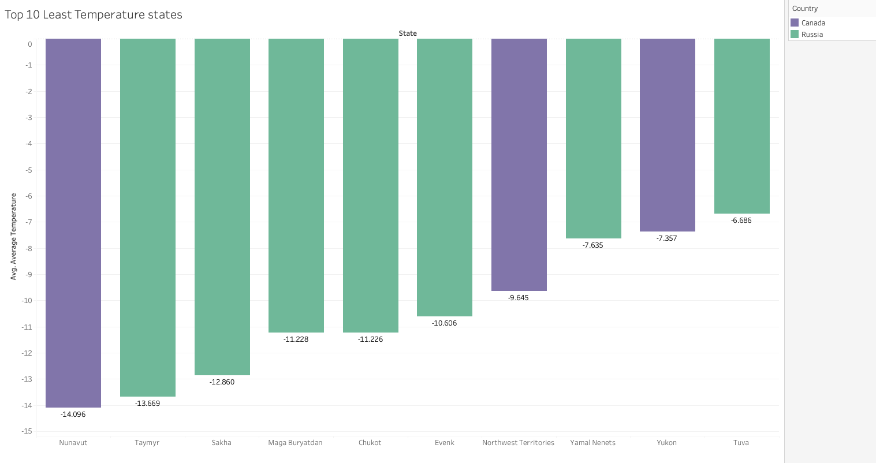
Description: Identifies coldest regions like Taymyr Peninsula.

Ocean vs Land Temperature Over Years
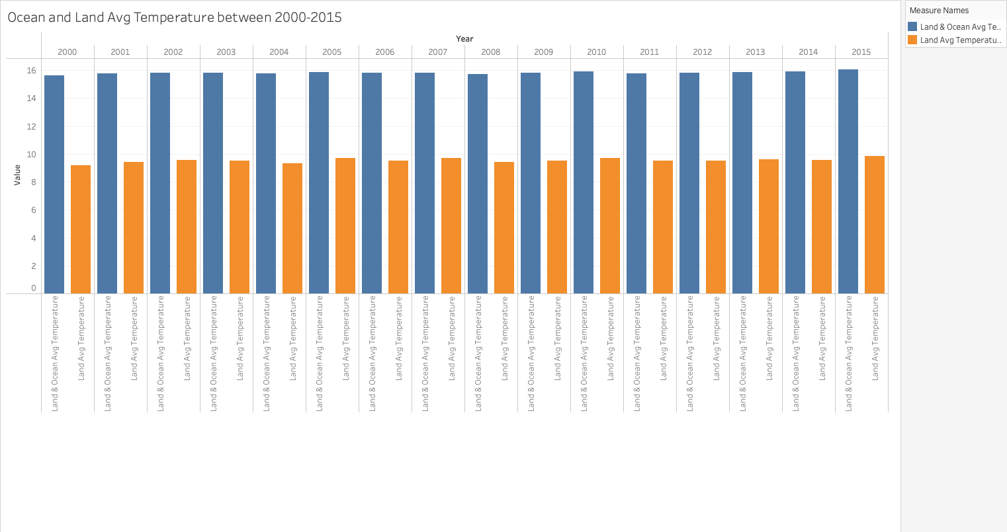
Description: Shows that land temperatures rise faster than ocean temperatures.

Top 5 Hottest Countries
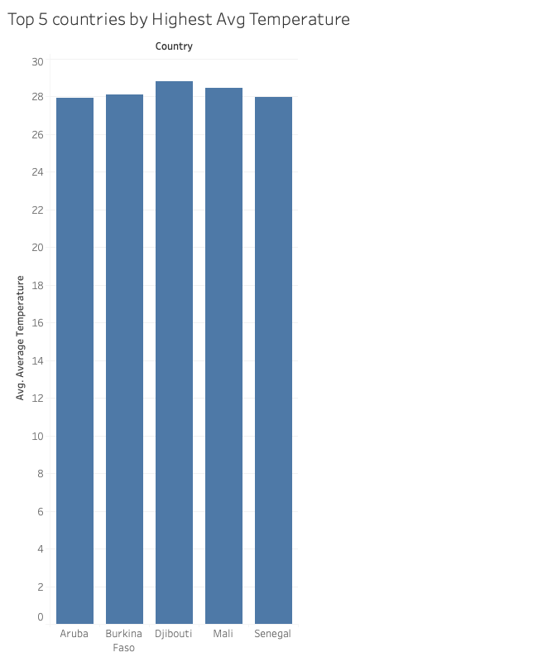
Description: Lists hottest countries; small island nations dominate.

LandMax Temperature by Year
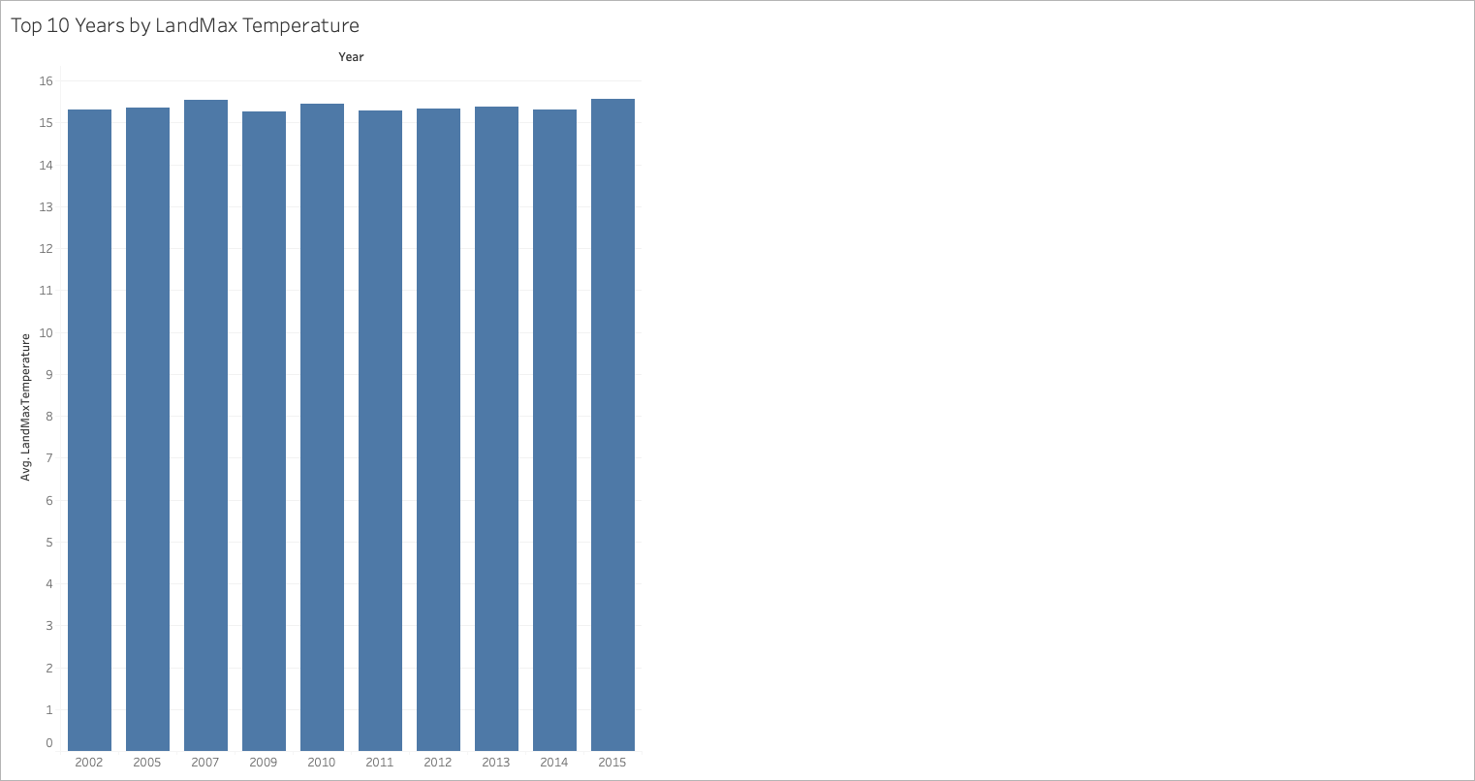
Description: Observes peak years for maximum recorded land temperatures.

Temperature Trend Comparison: Equator vs Poles
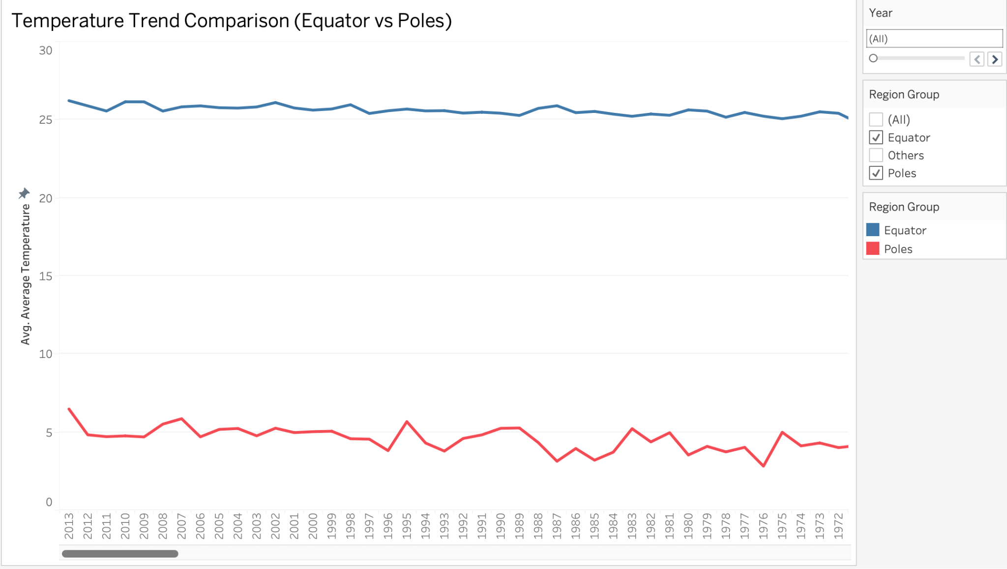
Description: New visualization showing faster polar warming compared to equator.

Tableau Dashboard
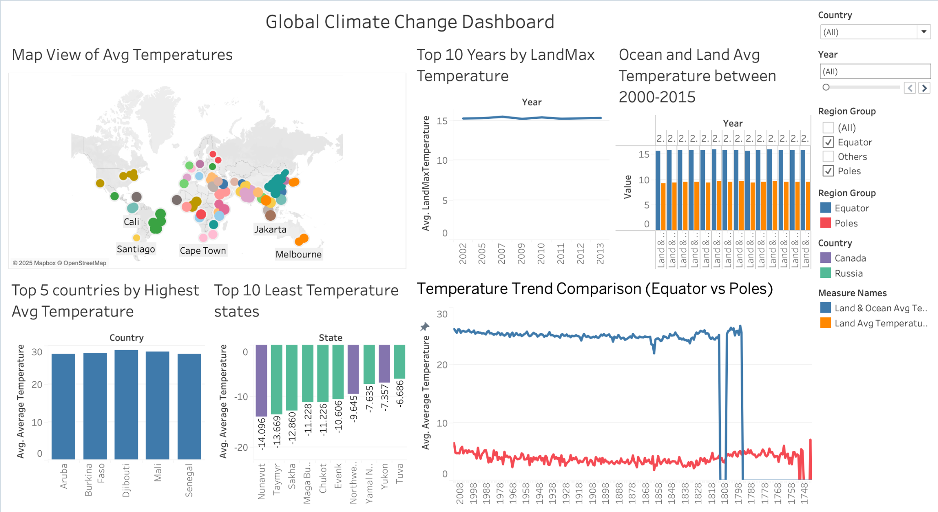
Insights:
- Easier comparison across regions.
- Allows for spotting rapid warming regions quickly.

7. Results and Analysis
Python Findings:
- Slightly increasing temperatures characterize the climatic trends in Equatorial countries.
- Global measurement uncertainty has demonstrated a downward trend based on the analysis of scatter plots.
- The main cluster of temperature data exists within temperate regions which span between 10°C–30°C.
- The visual hotspots in the Choropleth map emerge over time as part of global spatial data representation.

Tableau Findings:
- The temperature increase is occurring more rapidly on land-based areas than on maritime regions.
- The rankings of hottest countries determine that African countries along with small island nations consistently hold positions at the top.
- Polar countries show dramatic rises post-2005.
- The level of temperature uncertainty shows wide geographic differences between different continents.
Storytelling Approach:
Stage 1: Understanding and Exploring the Dataset:
- The first stage consists of understanding and exploring the dataset.
- Dataset Exploration: Research data came from the "Global Land Temperatures by Country" file available at Kaggle through Berkeley Earth.
- The study examined climate trends from 2000 until 2015 at the validation stage.
- Key Observations during Exploration:
  - Missing values existed, requiring cleaning.
  - The average temperature across multiple countries experienced significant modifications throughout the investigation period.
  - The temperatures in Russia and Canada together with additional polar regions displayed faster warming rates than other regions.
  - The high level of temperature uncertainty experienced before 2000 decreased as the time frame extended into the future.
  - The temperature in Equatorial nations across India experienced gradual warming at a steady pace.
Stage 2: Correlation Analysis and Data Transformation:
The process advances to Correlation Analysis while performing Data Transformation during Stage 2.

- Analyzing Relationships Between Variables:
  - Studies confirmed that newer years showed reduced levels of uncertainty while maintaining low uncertainty rates.
  - The positive relationship between years and national average temperatures reinforces global warming findings in most countries.
  - The temperature elevation in polar regions proved much more prominent than the temperature changes observed in equatorial regions.
- Data Transformations to Uncover Patterns:
  - The use of 3-year rolling averages helped eliminate cycles that disrupted seasonal temperature changes so trends could be accurately showcased.
  - Operators calculated national yearly mean data points to improve the clarity of trend assessment.
- Filtering:
  - Focused only on complete and relevant country-year pairs for stronger statistical reliability.
- Significant Pattern Discovery:
  - The regions near polar regions (such as Russia and Canada) experienced heating patterns that moved above the worldwide average temperature increase.
  - The smallest island countries repeatedly found their way into lists of countries with high temperatures.
  - Towards the coastal regions temperatures elevated at a slower pace in comparison to areas near land.
  - Absolute temperature fluctuations were wider in regions with colder climates because statistical analysis showed through box plot visualizations and data frequency distributions.

8. Work Management
Implementation Status Report:
- The project "Understanding Global Climate Change" achieved complete completion through its progression from data acquisition to data purification and feature design and finally visualization design along with dashboard development.
- The temperature dataset extending from 2000 to 2015 received visual interpretation through interactive dashboards which developers constructed using Python (Dash, Plotly) and Tableau. Static visualizations accompany two finished dashboards (Python and Tableau) with a complete results evaluation.
Team Contributions:
Three team members worked together to finish the project requirements. The team allocated different parts of the project work to each member.
Member 1 devoted their effort to data cleaning and Python dashboard development through Dash and Plotly and the creation of line plot static visualizations, scatter plots and choropleth map visualizations.
Member 2 performed the tasks of developing Tableau dashboards, created features by applying rolling averages and conducted investigative data analysis.
Member 3 The report writing phase alongside extracting insights and creating implementation documents as well as conducting a comparison of Python and Tableau outputs .

10. Discussion
The dashboard tools from Python and Tableau showcased different capabilities in their system design structures:
- Python Dashboard: Highly interactive, flexible filtering, dynamic visuals.
- Tableau Dashboard: Faster exploratory analysis, beautiful map-based insights.
Common Findings:
- Ear-marked Polar Amplification is real and can be viewed through observations.
- The ocean heat content operates as a temporary protecting system so has time limits.
- The reduction of uncertainty in climate data occurs as new technological advancements take effect.
The analysis using dual tools enabled complete observation of global warming trends.

11. Conclusion
- The extensive examination of climate change effects through visual representation data served as the main objective of this project.
- The combination of Python and Tableau proved effective for dashboard production which led to finding concealed patterns.
- Scientists have observed that Earth's temperature keeps increasing most quickly in the polar regions.
- Visual data storytelling provides essential roles in both public awareness development and policy creation guidance.
- Further work on this study should involve the incorporation of CO2 emission data alongside GDP growth and population statistics.

12. References
- Kaggle - Berkeley Earth Dataset: https://www.kaggle.com/datasets/berkeleyearth/climate-change-earth-surface-temperature-data
- Dash (Plotly) Documentation: https://dash.plotly.com/
- Tableau Public Resources: https://public.tableau.com/en-us/s/resources
- IPCC Climate Change Report 2021
- NASA Global Climate Change Portal
- Our World In Data - Climate Change Datasets
- Pandas Python Documentation
- NumPy Python Documentation
- Plotly Express Python Visualization Library
- JupyterDash Documentation
- Tableau Community Best Practices

